Supplemental Information
Methane Flux Dynamics in a Submerged Aquatic Vegetation Zone in a Subtropical Lake
Mi Zhang^{1,5}, Qitao Xiao³, Zhen Zhang¹, Yunqiu Gao⁴, Jiayu Zhao¹, Yini Pu¹, Wei Wang¹, Wei Xiao¹, Shoudong Liu¹, Xuhui Lee^{1,2*}

¹Yale-NUIST Center on Atmospheric Environment, International Joint Laboratory on Climate and Environment Change (ILCEC), Nanjing University of Information Science and Technology, Nanjing, 210044, China
²School of Forestry and Environmental Studies, Yale University, New Haven, CT 06511, USA
³Key Laboratory of Watershed Geographic Sciences, Nanjing Institute of Geography and Limnology, Chinese Academy of Sciences, Nanjing, 210008, China
⁴Hangzhou Chaoteng Energy Technology Co., Ltd, Hangzhou, 310051, China
⁵ NUIST-Wuxi Research Institute, Wuxi, 214105, China

Table S1. Water quality parameters in the submerged aquatic vegetation zone in Lake Taihu
 | Area  (km²) | DOCª  (mg·L⁻¹) | TP^{b}  (mg·L⁻¹) | TN^{b}  (mg·L⁻¹) | Clarity  (m) | DOª  (mg·L⁻¹)
 | 316.4 | 3.65 | 0.04 | 1.27 | 0.51 | 9.07
a The DOC and DO data were obtained from the database of the Chinese National Ecosystem Observation Research Network. The DOC and DO were average values for 2013 to 2014.
b The TP and TN data were obtained from the Taihu Basin Authority of Ministry of Water Resources and Electric Power. The TP and TN were average values for 2014 to 2016.
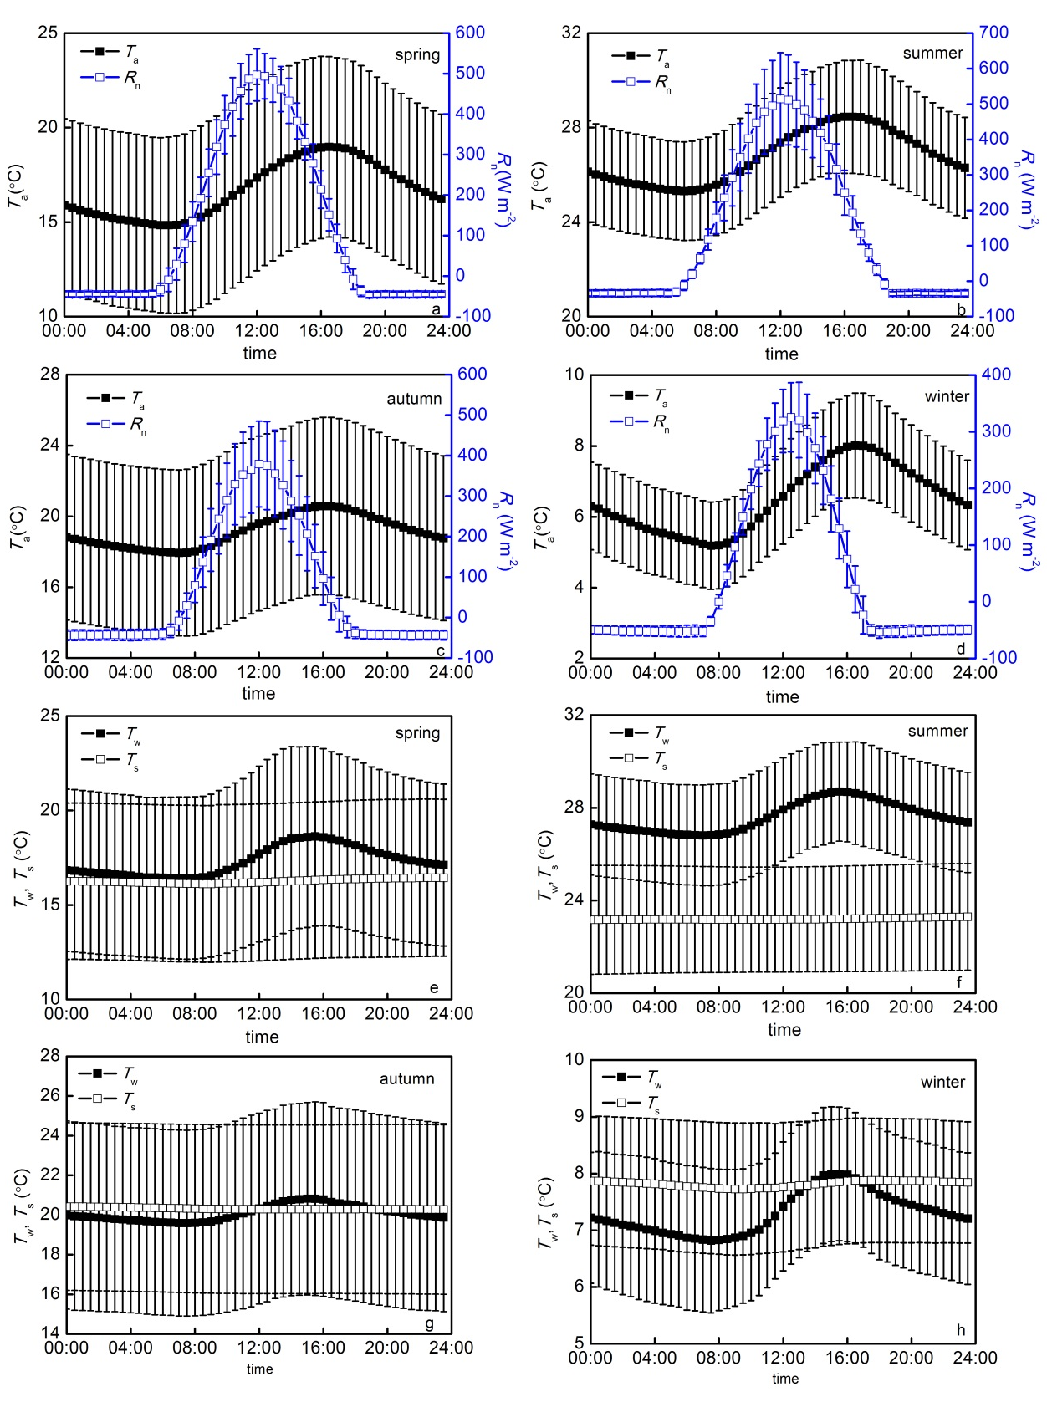
Figure S1. Diurnal composites of air temperature (T_{a}), net radiation (R_{n}), water temperature at the 20-cm depth (T_{w}), and sediment temperature (T_{s}) at BFG. Error bars are ± one standard deviation.

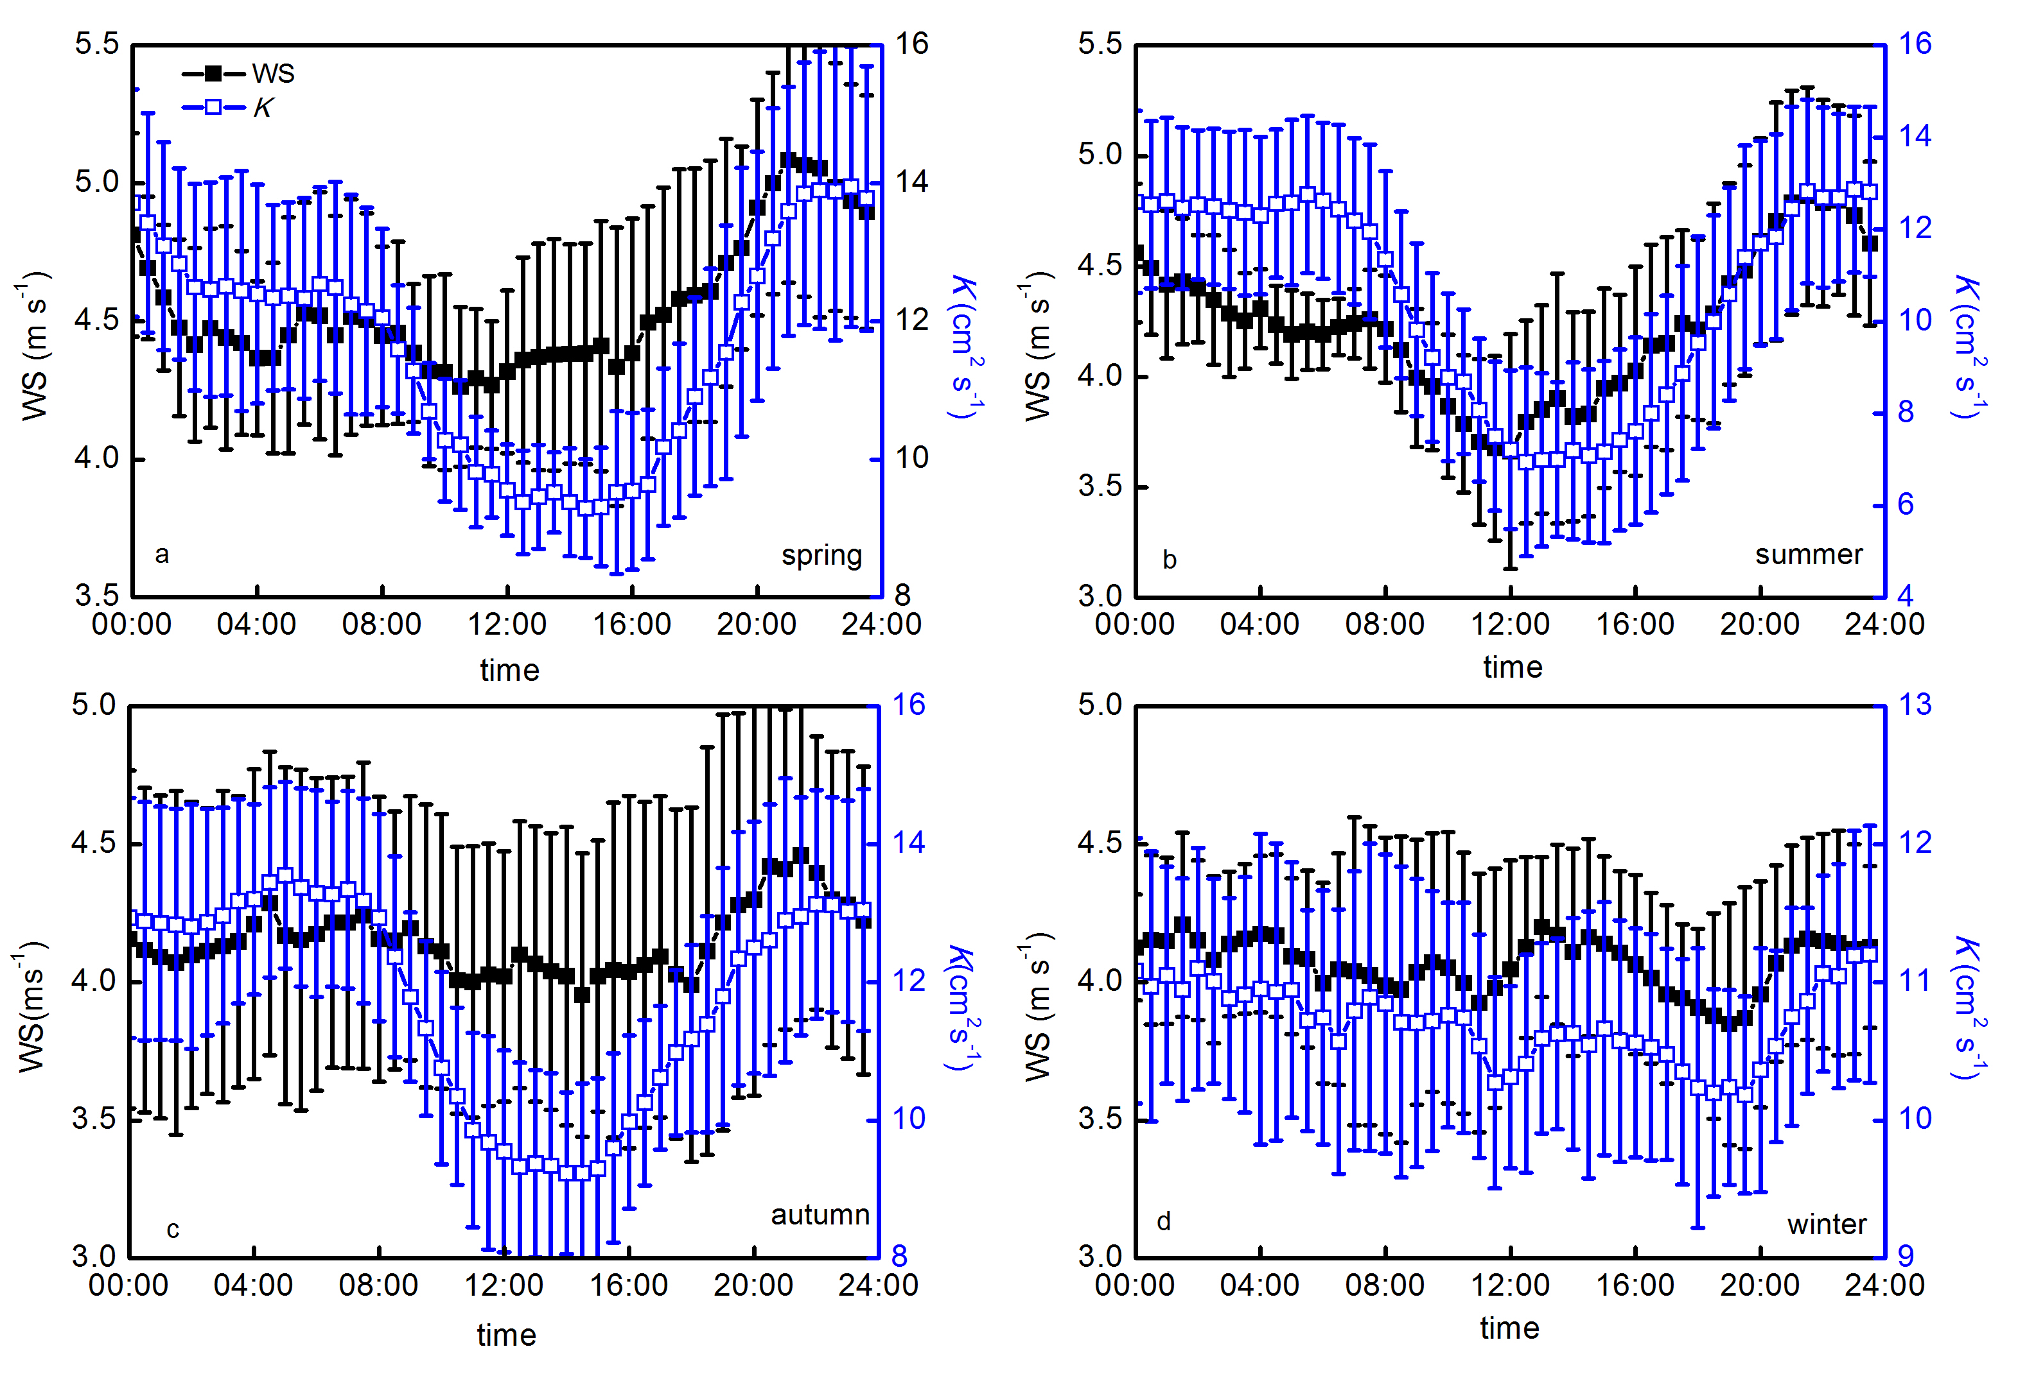
Figure S2. The diurnal composite wind speed (WS) and turbulent diffusion coefficient (K) at the 20-cm water depth at BFG in the spring (a), summer (b), autumn (c), and winter (d) at BFG. Error bars are ± one standard deviation.

Figure S3. The average diurnal variation of water temperature in the spring (a), summer (b), autumn, and winter (d) at BFG.

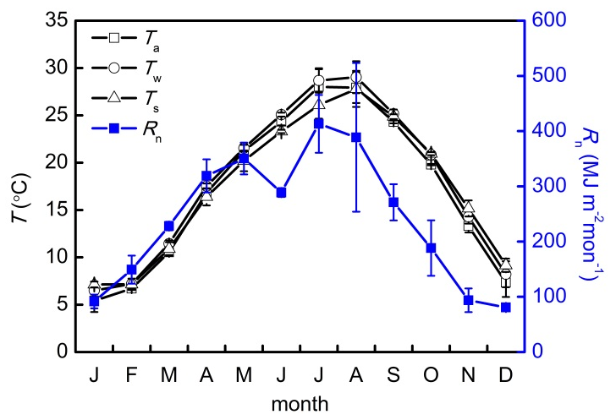
Figure S4. Average monthly air temperature (T_{a}), net radiation (R_{n}), 20-cm water temperature (T_{w}), and sediment temperature (T_{s}) from 2014 to 2017 at BFG. Error bars are ± one standard deviation.

Figure S5. Temporal dynamic of CH₄ flux (F_{m}) in the submerged aquatic vegetation zone of Lake Taihu. Black dots: 30 min data; Red circles: 5 days mean F_{m}.

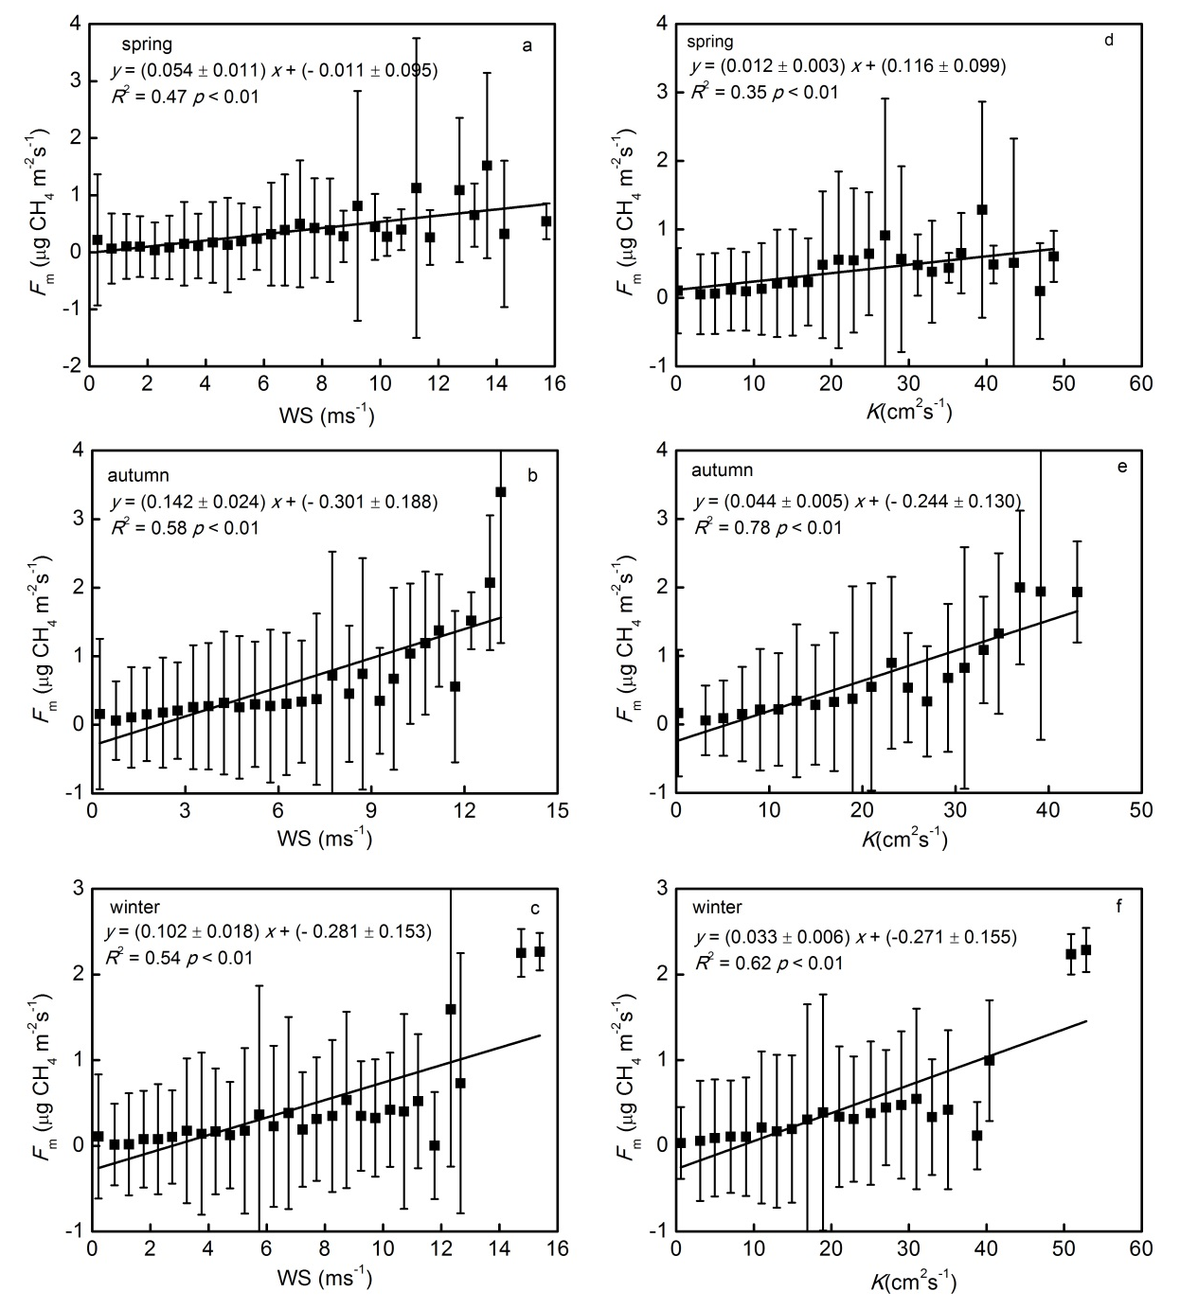
Figure S6. Relationships between the CH₄ flux (F_{m}) and wind speed (WS) (a-c) and between the CH₄ flux (F_{m}) and the turbulent diffusion coefficient (K) at 20-cm water depth (d-f) in the spring, autumn, and winter at BFG.

